1.a) Website Objectives
The objective of the Chess tutoring website is for teaching its users the skills required to improve the users play for a country to encourage that do it like FIDE to garner interest in
b) Target Audience
Beginner chess players and intermediate chess players who may have an interest in real life chess tournaments as well as hobbyists who sometimes
Demographics:
- Ages 13-45, including students, working professionals.
- General digital familiarity
- Those who may have little exposure to professional chess structures as the site acts as a friendly introduction.
c) Type of Website
The site is a chess educational and training platform. The content will host a store of all popular chess openings, middlegame & endgame tips. with video demonstrations as well as a chess engine with adjustable strength hosted on the website to practice against. It will also host access to physical chess clubs to encourage people
2.1Information Architecture
a) the website content is organized into categories
Main Categories
- Home – Entry
- About – Background information
- Learn Chess – Tutorial, lessons, and structured training
- Community – Physical club directory
- Practice Tools – Interactive training tools, engine, tactics
- Contact & Feedback – Contact info
2.2 Sitemap
Below is the sitemap for the chess tutoring website:

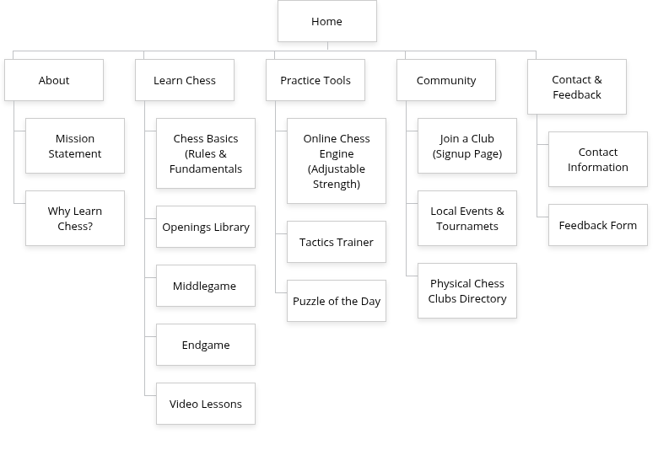
2.3 Navigation Paths
The website will use a top navigation bar visible on all pages for quick access to every section.
Primary navigation (Always Visible)
- Home
- About
- Learn Chess
- Practice Tools
- Community
- Contact & Feedback
Secondary Navigation (Inside Sections)
2.4 Storyboard / Flowchart
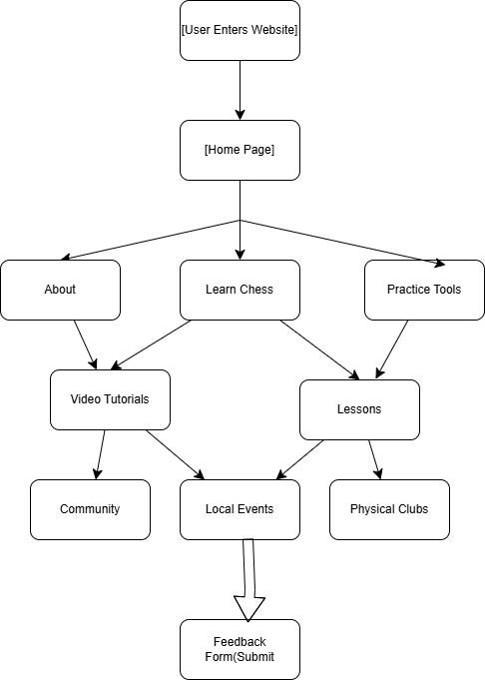
3. Page Template Design
These are the page template designs
3.1 Page Template: Home Page
Layout Description
The Home Page uses a clean layout that quickly introduces the user to the site’s purpose and primary features.
Wireframe Structure
Header (fixed at top)
- Logo
- Navigation menu (Home | About | Learn Chess | Practice Tools | Community | Store | Contact)
Hero Section
- Large banner image or illustration
- Headline: “Improve Your Chess Skills—From Beginner to Intermediate”
- Call-to-action button: Start Learning
Featured Sections (3-column layout)
- Learn Chess (icon + short description)
- Practice Tools (icon + short description)
- Local Chess Clubs (icon + short description)
Highlight Section
- Featured video lesson or lesson preview
Footer
- Quick links, social icons, contact details

3.2 Page Template: Learn Chess Page
Layout Description
The Learn Chess page presents categorized educational content.
Wireframe Structure
Header
Page Title: Learn Chess
Side Navigation Panel (left column):
- Chess Basics
- Openings
- Middlegame
- Endgame
- Video Lessons
Main Content (right column):
- Section title (e.g., “Openings Library”)
- Visual diagram of opening
- Text explanations
- Embedded practice board (optional)
Footer

3.3 Page Template: Practice Tools Page
Layout Description
This page provides access to the interactive tools that help users train.
Wireframe Structure
Header
Main Tools Grid (3-column layout):
- Chess Engine (Adjustable Strength)
  - Start button
  - Strength slider
- Tactics Trainer
  - “Start Puzzle” button
- Puzzle of the Day
  - Automatically loaded puzzle
Below Tools:
- Recent results
- Training history (optional future development)
Footer

3.4 Page Template: Community Page
Layout Description
Encourages users to join real-life chess communities.
Wireframe Structure
Header
Section Title: Community Hub
Two-Section Layout:
Left: Physical Chess Clubs Directory
- List of clubs
- Map (optional)
- “Join Now” buttons
Right: Local Events & Tournaments
- Events list
- Dates, locations
- Registration button
Footer

3.5 Page Template: Contact & Feedback Page
Layout Description
Contains the required HTML form.
Wireframe Structure
Header
Page Title: Contact & Feedback
Two Sections:
Left: Contact Information
- Email
- Phone
- Physical address (optional)
Right: Feedback Form
- Full Name (input)
- Email (input)
- Message (textarea)
- All fields marked as required
- Submit button (HTML form submission)
Footer

4.1 Web Development Technologies
1.HTML5
- Used to build the structural layer of the website
- Supports embedding multimedia for lesson videos and interactive content
2.CSS3
– Used for styling the website’s presentation layer.
3.JavaScript
-Used for interactive components, including:
- Tactics trainer
- Menu interactions
- Puzzle Generator
- Form validation
- Supports the embedding of a chess engine like Stockfish.js
4.2 Frameworks and Libraries
Bootstrap 5
- Used for responsive design and grid layout.
- Ensures usability across devices: mobile, tablet, and desktop.
- Provides pre-built components such as:
  - Navigation bars
  - Cards
  - Buttons
  - Forms
Stockfish.js (Chess Engine)
- A lightweight, open-source chess engine compiled to JavaScript.
- Enables an adjustable-strength engine to be placed directly
4.3 Software & Tools Used
1. Visual Studio Code (VS Code)
- Primary development environment.
- Extensions used may include:
  - Live Server
  - HTML/CSS/JS IntelliSense
  - Prettier (code formatting)
2. Git & GitHub
- Used for version control and collaboration.
- The GitHub repository will host:
  - HTML files
  - CSS files
  - JavaScript files
  - Images and lesson resources
- GitHub Pages will be used to publish the live website.
3. Canva
Used for creating graphics, like:
- Logo design
- Website icons
- Banner images
- Page layout mock-ups and wireframes
This tool will ensure clean, modern graphics aligned with the theme of the website.

4.4 Multimedia Tools
Video Hosting
- Tutorial videos may be:
  - Embedded from YouTube (unlisted mode), or
  - Hosted locally inside the website folder
- HTML5 video tags will be used for playback.
Image Optimization Tool (Timing / Squoosh)
- Used to compress images to improve loading speed.
- Ensures optimal performance on mobile devices.

4.5 Testing Tools
Browser Testing
- Website will be tested on:
  - Google Chrome
  - Mozilla Firefox
  - Microsoft Edge
  - Opera
  - Safari
Device Testing
- Chrome Developer Tools (Device Mode) will be used to test:
  - Mobile responsiveness
  - Tablet layouts
  - Desktop scaling

4.6 Hosting & Deployment Technologies
GitHub Pages
- Used for deployment of the live website.
- Offers free static hosting.
- Git commands such as:
  - git add
  - git commit
  - git push
will be used to update the site.

